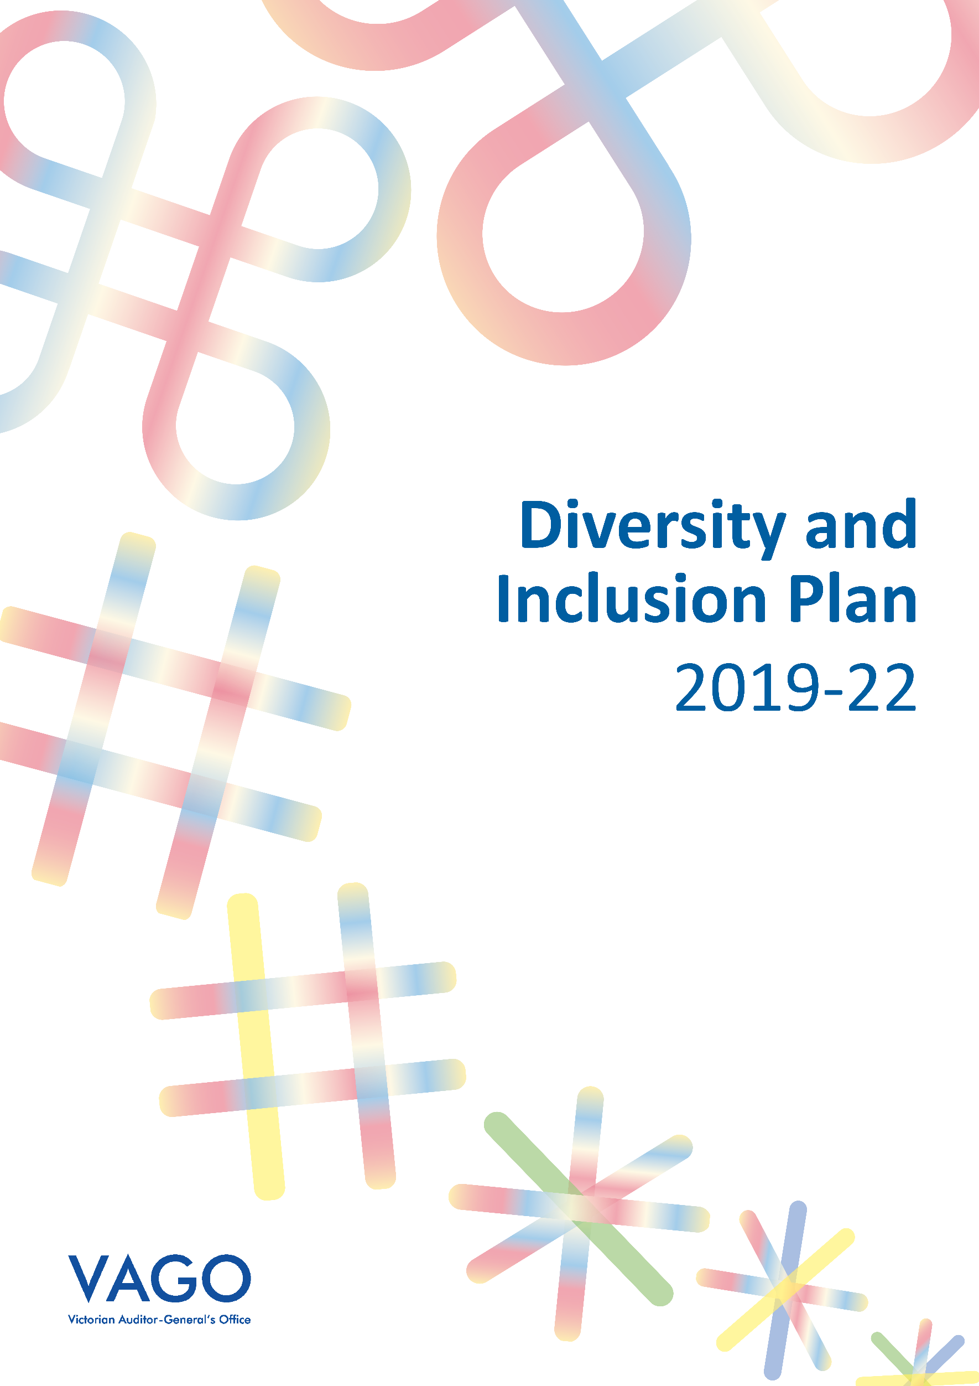

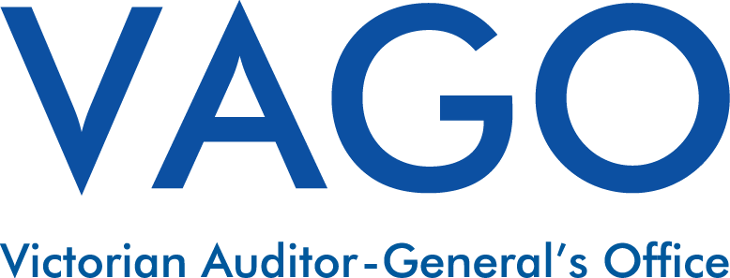

Diversity and Inclusion Plan 2019–22
Contents
Table of Contents
Acronyms and abbreviations 4
Auditor-General’s Foreword 5
Introduction 6
What does diversity mean to us? 6
Aboriginal Inclusion 7
Cultural Diversity 8
Disability Inclusion (focus on Ability) 8
LGBTI Inclusion 9
Women at Work 9
How we will create a more inclusive culture 10
Phase 1: Raising awareness 11
Phase 2: Internal education and introduction of new practices 11
Phase 3: External engagement 11
How we will evaluate success 12
Appendix 1: 2019-22 Diversity and Inclusion Action Plan 13

Acronyms and abbreviations
VPS Victorian Public Sector
VPSC Victorian Public Sector Commission
LGBTI Lesbian Gay Bisexual Transgender and Intersex
IPAA Institute of Public Administration Australia
DHHS Department of Health and Human Services
RAP Reconciliation Action Plan
WCAG Web Content Accessibility Guidelines
CAANZ Chartered Accountants Australia and New Zealand
CPA Certified Public Accountant
AWEI Australian Workplace Equality Index

Auditor-General’s Foreword
I’m proud to launch VAGO’s first diversity and inclusion plan, which we developed in recognition of our commitment to be a diverse, fair and inclusive workplace.
We recognise that an organisation performs its best when the diverse qualities of our people are understood, respected and celebrated. Embracing diversity and implementing inclusive practices provides new ideas, skills and experience.
As highlighted in our Strategic Plan, we aspire to become the model public sector organisation that our position demands and that the Victorian public expect us to be. To achieve this, it is important that our profile reflects the community we serve, and that our environment and the way we work is inclusive to all.
Once this plan is implemented we will have increased our awareness and understanding of diversity within the Victorian community, and our capability to recognise and remove barriers for inclusion. As a result, we and the Victorian community will benefit from the expanded insights this diversity will bring.

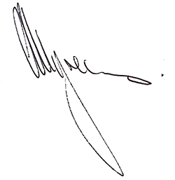

ANDREW GREAVES
Auditor-General

Introduction
As we increase our focus on diversity and inclusion at VAGO through this diversity and inclusion plan, we will concentrate our efforts in a phased approach over a three-year period so that the implemented changes are successfully and meaningfully embedded.
The phases we will undertake include:
- raising awareness;
- internal education and introduction of new practices; and
- external engagement.
Five employee representative groups were set up to champion, consult and advise on our focus areas, including:
- Aboriginal Inclusion
- Cultural Diversity
- Disability Inclusion (Focus on Ability)
- LGBTI Inclusion
- Women at Work.

What does diversity mean to us?
Workplace diversity is the varied characteristics held by our employees and stakeholders. These characteristics may include, but are not limited to:
- ethnicity
- cultural and religious beliefs
- gender and sexual identity
- age
- education
- physical and mental ability.
Inclusion means that all people are respected, valued, and invited to take part in a meaningful way with equitable opportunity, free from discrimination.

Aboriginal Inclusion
We proudly acknowledge Victoria’s First Nations peoples and their ongoing strength in practising the world’s oldest living culture. We acknowledge the Traditional Owners of the lands and waters on
which we live and work and pay our respects to their Elders past, present and emerging. We recognise the contribution of Aboriginal people and communities to Victorian life and how this continues to enrich our society more broadly.
As at 1 January 2019, no current VAGO employee has chosen to identify as Aboriginal through our on-boarding processes. Through the implementation of this plan, we hope to develop a culturally safe environment for existing or future employees who choose to identify.
VAGO has never had an inclusion strategy for Aboriginal employees or one that informs our engagement with Aboriginal communities. The initiatives within this plan will serve as the building blocks to develop cultural safety for future Aboriginal employees through a process of building cultural awareness and cultural competence. We also aim to effectively skill ourselves to engage more often—respectfully and meaningfully—with a wider range of communities as we undertake our work.
In late 2018, our employee representative group for Aboriginal Inclusion and our Human Resources team attended cultural awareness training. In undertaking the implementation of this plan, we commit to continuing to engage with the networks developed through this training to support us in achieving the initiatives we have set out to complete.

Cultural Diversity
Effective cross-cultural engagement and communication is important for a productive, inclusive and well-functioning workplace.
In 2018, information from our human resources information system shows that our workforce includes 18 different nationalities. Within our 2018 People Matter Survey, 44 per cent of respondents were born in a country other than Australia.
With more than 30 per cent of Victorian residents born overseas, a workforce that represents our multicultural community is a valuable asset to help us best serve Victoria. It is equally important that our employees come to a workplace that understands, supports, respects, and celebrates their cultural characteristics.
As we implement the initiatives within this plan we will continue to use the experience and knowledge of the diverse cultures within our organisation. In doing so, we aim to further recognise and celebrate the value of cultural and religious diversity, both within our organisation and the wider Victorian Community.
Disability Inclusion (focus on Ability)
People with a disability form 18.4 per cent of the Victorian population. Of this, six per cent have a profound or severe disability.
At 1 January 2019, no current VAGO employee has formally disclosed that they have a disability or requested adjustments for a continuing disability. However, within our 2018 People Matter Survey results 4 per cent of respondents selected ‘yes’ and 6 per cent selected ‘prefer not to say’ when asked whether they have a disability.
Through implementation of this plan we aim to focus on the abilities of all people and achieve a workplace that is inclusive and welcoming of individuals who have a physical or non-physical disability.
We plan to directly engage with people who have a disability to better understand what barriers exist and how we can improve the accessibility of both our physical workplace, our ways of working and the work we produce. Achieving this will also assist us in eradicating any unintentional, indirect or direct disability discrimination.

LGBTI Inclusion
LGBTI represents Lesbian, Gay, Bi-sexual, Trans, Gender Diverse and Intersex people. In 2018, our People Matter Survey showed that 6 per cent of our workforce are same sex attracted, asexual, bisexual or pansexual and 17% of our workforce preferred not to disclose their sexual orientation.
Sexuality and gender identity are a major part of who we are as individuals. A large number of LGBTI people hide their sexuality or gender identity when accessing services (34 per cent), at social and community events (42 per cent) and at work (39 per cent).
Through implementation of this diversity and inclusion plan we aim to raise awareness and promote ally engagement so that all our employees feel safe and encouraged to be who they are at work.
Women at Work
We’re committed to a workplace that values all contributions equally and achieves equal outcomes for our people, regardless of gender or carer status.
Whilst 57 per cent of VAGO’s total workforce were women at the last pay of 2018, women made up only 30 per cent of our employees at the Executive Officer level.
Through implementation of this plan we commit to continuing our support for women in the workplace with a longer-term goal to achieve a gender balanced executive group.
We will continue to develop capability to be flexible and balance the work life blend for all our employees and commit to eradicating any discrimination because of gender and/or caring responsibilities.

How we will create a more inclusive culture
The Diversity and Inclusion Action Plan 2019-22 (the action plan)–attached at Appendix 1–has been developed in consultation with our employee representative groups.
We also engaged important external stakeholders to guide the development of this plan, including the Koori Heritage Trust, the Aboriginal Employment Unit from the Victorian Public Sector Commission, The VPS Pride Network, The National Institute for Challenging Homophobia Education and the VPS Enablers Network. We will continue to engage these bodies–and others–as we implement the initiatives within the action plan.
A diversity and inclusion working group will lead and champion the implementation of the action plan, including consultation with key internal and external stakeholders and monitoring and evaluation of progress.
Implementation of the action plan will occur in three phases. It is important to note that for each diversity focus area the implementation phases will progress according to our developing awareness and maturity, but will meet the implementation deadlines specified within Appendix 1 as a minimum.

Phase 1: Raising awareness
To do this we will:
- Develop a diversity and inclusion working group to champion inclusion at VAGO, with an executive sponsor appointed to support the implementation of this plan.
- Implement an annual calendar of events to celebrate and raise awareness of diversity and inclusion matters.
- Expand the availability and promotion of resources to increase the level of cultural and social awareness amongst our staff, including respectful terminology factsheets to aide VAGO in the production of inclusive and respectful content and contact lists of key reference agencies.
- Encourage self-disclosure, to assist VAGO in the collection of diversity focused people metrics, to set a benchmark and enable monitoring of changes to VAGO’s demographic.
- Engage with Public Sector led networks and communities of practice.

Phase 2: Internal education and introduction of new practices
To do this we will:
- Implement targeted diversity focused learning and development, to ensure the right people have the right skills and knowledge when engaging with diverse communities.
- Review existing e-Learning compliance training modules to incorporate diversity content and consider development of a standalone diversity focused module.
- Review recruitment and on boarding procedures in consultation with the diversity and inclusion working group to ensure our practices are free from unintended bias and are inclusive for a diverse range of people.
- Undertake a review of our work environment with a view to implement changes to our physical environment and the way we work to facilitate inclusiveness for a diverse range of people.
Phase 3: External engagement
To do this we will:
- Increase engagement with diverse groups and their allies during annual planning and when undertaking audit work.
- Explore engagement with specialised external bodies during recruitment to promote VAGO as an inclusive workplace.
- Obtain evaluation and endorsement of VAGO’s diversity and inclusion effort by undertaking assessment via externally recognised bodies.

A more detailed overview of initiatives and actions for each diversity focus area is included in the action plan at Appendix 1.

How we will evaluate success
Implementation of the action plan within the set timeframes and with participation from the diversity and inclusion working group and wider business will be an indicator that we are achieving the goals of this plan.
Raising awareness, continuing the ongoing conversation and increasing engagement around diversity and inclusion at VAGO will show our commitment to continually developing as an inclusive workplace.
Human Resources will oversee delivery of this plan, with monthly reports on progress provided to VAGO’s Operational Management Group.
In addition, we will monitor and evaluate our success regularly through the following mechanisms:
- Feedback and information received from the annual People Matter Survey.
- Feedback from our diversity employer representative groups.
- Monitoring of changes in our diversity focused people metrics.

Appendix 1: 2019-22 Diversity and Inclusion Action Plan
Phase 1: Raising awareness (Implemented before 30 January 2020)
Diversity and Inclusion Plan reference | Stream specific actions
 | Women @ Work | Cultural Diversity | Aboriginal Inclusion | LGBTI Inclusion | Focus on Ability
Develop a diversity and inclusion working group to champion inclusion at VAGO, with an executive sponsor appointed to support the implementation of this plan. | Establish a diversity and inclusion working group who will lead and champion the implementation of actions and initiatives and be involved in consultation with relevant stakeholders. Involvement from employee's will be documented and recognised through performance appraisals.
Implement an annual calendar of events to celebrate and raise awareness of diversity and inclusion matters. | Develop a calendar of events for days of significance and various awareness days to promote and/or celebrate. This can also include engaging relevant speakers to present to staff or holding lunchtime events.
Expand the availability and promotion of resources to increase the level of cultural and social awareness amongst our staff, including respectful terminology factsheets to aide VAGO in the production of inclusive and respectful content and contact lists of key reference agencies. |  | Develop or source resources to be made available to staff for cultural diversity and inclusion. | Start VAGO staff events, and external events representing VAGO, with an Acknowledgment of Traditional Owners (e.g. staff forums, stand-up briefings). Develop a 1 page guidance note for staff based on information published by Aboriginal Victoria.  Provide guidance materials to improve employees capacity to engage with Aboriginal people and increase their cultural and social awareness. The types of materials to consider are:  • respectful terminology factsheets to assist with report writing  • resource links such as DeadlyQuestions.vic.gov.au  • subscription to Koori Mail a regular newsletter.  Make resources easily accessible to our staff.  Utilise VPS templates for email signatures to promote Aboriginal inclusion. Provide guidance on employee use of such templates. | Utilise VPS templates for email signatures to promote LGBTI+ inclusion. Provide guidance on employee use of such templates.  Make resources such as articles, terminology factsheets easily accessible to our staff. | Utilise VPS templates for email signatures to promote disability inclusion. Provide guidance on employee use of such templates.
Encourage self-disclosure, to assist VAGO in the collection of diversity focused people metrics, to set a benchmark and enable monitoring of changes to VAGO’s demographic. | Raise awareness of and celebrate VAGO’s diverse workforce by promoting diversity data through VAGO's staff pulse.
Engage with Public Sector led networks and communities of practice. | Review and consider engagement with the IPAA Victoria Women in Leadership in the Public Sector Framework when it rolls out. |  | VAGO to engage with and promote the work of the VPSC Aboriginal Employment Unit. | VAGO to engage with and promote the work of the Pride Network (the public sector’s network for LGBTI employees and their allies). | VAGO to join Diversity Community of Practice (DHHS-led)  VAGO to engage with and promote the work of the Enablers Network (the public sector’s network for employees with disability and their allies).

Phase 2: Internal education and introduction of new practices (Implemented before 30 January 2021)

Diversity and Inclusion Plan reference | Stream specific actions
 | Women @ Work | Cultural Diversity |  | Aboriginal Inclusion | LGBTI Inclusion | Focus on Ability
Implement targeted diversity focused learning and development, to ensure the right people have the right skills and knowledge when engaging with diverse communities. | Manager training: Managing flexible working arrangements  Increase our capability in inclusive recruitment practices, including unconscious bias training—for recruitment panel members |  |  | Offer face-to-face training to all VAGO staff in Aboriginal Cultural Awareness.
Review existing e-Learning compliance training modules to incorporate diversity content and consider development of a standalone diversity focused module. | Review existing e-Learning compliance training modules to incorporate diversity content and develop a stand alone Diversity focused module.
Review recruitment and on boarding procedures in consultation with the diversity and inclusion working group to ensure our practices are free from unintended bias and are inclusive for a diverse range of people. | Review recruitment marketing and communications practices to include greater consideration of how we advertise, attract and engage with diverse applicants (e.g. reflect diversity and inclusion at VAGO in job advertisements, position descriptions, interview questions, on boarding procedures and provide appropriate training and guidance to interview panels)
Undertake a review of our work environment with a view to implement changes to our physical environment and the way we work to facilitate inclusiveness for a diverse range of people. |  |  |  | Develop a Reconciliation Action Plan (RAP) in conjunction with Reconciliation Australia.  Display local Aboriginal artwork across Levels 31 and 32 (including with consideration of meeting spaces). This visual signal of Aboriginal culture is a practical way of promoting cultural safety.  (Note: this could include a revision to VAGO’s current hire agreement with Art Bank to include a selection of artwork by local Aboriginal artists. This may be done with the assistance of the Koorie Heritage Trust (who maintain a list of local Aboriginal artists), and in line with the City of Melbourne’s Code of Practice for galleries and retailers of Aboriginal art).  Display a plaque at reception to demonstrate respect and awareness that VAGO’s existence is on Wurundjeri land. |  | Conduct an accessibility/ability audit of VAGO’s physical and non-physical structures and frameworks to identify barriers to VAGO supporting and embracing the employment of people with a disability and the ability of our stakeholders with disabilities to access our office and services. Consider recommendations and implement appropriate changes (implementation to occur during phase 2 and 3)  Start using the VAGO pedestal speaker and lapel microphone system at VAGO Stand Ups and other large gatherings of staff.  Rectify known issues with the VAGO website to achieve compliance with Web Content Accessibility Guidelines (WCAG) version 2.0 Level AA and the Victorian Government standards and guidelines. (Note: this work is currently underway through a contract variation with our website provider.)  Promote the availability of dictation software to VAGO employees, including advice and guidance on how to use this software and the availability of quiet rooms to utilise the software.

Phase 3: External engagement (Implemented before 30 January 2022)

Diversity and Inclusion Plan reference | Stream specific actions
 | Women @ Work | Cultural Diversity | Aboriginal Inclusion | LGBTI Inclusion | Focus on Ability
Increase engagement with diverse groups and their allies during annual planning and when undertaking audit work. | The Senior Executive Group commit to the Male Champions of Change Panel Pledge, which is a commitment to make appropriate enquiries about gender representation when you are invited to speak or participate in a professional forum. Communicate this commitment to VAGO staff so they can support delivery of commitment and commit to taking gender balance into account for VAGO managed forums and events.  Engage with Male Champions of Change to discuss the possibility of forming or participating in existing Male Champions of Change groups. | Engage with the Victorian Multicultural Commission to explore and consider multicultural affairs and issues during annual planning and audits. Promote this engagement via the Voice of VAGO to increase visibility of this step in the process. | Increase engagement with Aboriginal groups during annual planning and audits (e.g. consider inclusion of a reminder in AmP step as part of audit process). Promote this engagement via the Voice of VAGO to increase visibility of this step in the process.  Include acknowledgement of Aboriginal people and Aboriginal artwork in publications such as annual report and audit reports. Note: This may be done with the assistance of the Koorie Heritage Trust (who maintain a list of local Aboriginal artists), and in line with the City of Melbourne’s Code of Practice for galleries and retailers of Aboriginal art.
Explore engagement with specialised external bodies during recruitment to promote VAGO as an inclusive workplace. | Engage with Women Victoria to explore how VAGO, and our employees, can become involved in future Women’s Leadership programs. |  | Commit to further exploration of employment initiatives for Aboriginal people, such as:  • Establish link to Aboriginal Accountants Australia, a joint initiative of CAANZ and CPA Australia for VPS or graduate / intern program;  • Intern program through Career Trackers, a national not-for-profit organisation supporting career aspirations for Aboriginal and Torres Strait Islander university students http://www.careertrackers.org.au/employers/  • Aboriginal Undergraduate Cadetship Program https://vpsc.vic.gov.au/aboriginal-employment/our-programs/aboriginal-undergraduate-cadetship-program/  • Aboriginal people specific secondment arrangements  • Leadership Academy for Aboriginal leaders (senior, executive roles). |  | Commit to further exploration of employment initiatives for people with a disability through engagement with JobAccess https://www.jobaccess.gov.au/
Obtain evaluation and endorsement of VAGO’s diversity and inclusion effort by undertaking assessment via externally recognised bodies. | Undertake the Workplace Gender Equality Agency's Employee Opinion Survey with VAGO staff and report back the results to all staff |  |  | Participate in the 2021 Australian Workplace Equality Index (AWEI) and benchmark results to identify action areas for future diversity plans, and refresh LGBTI+ inclusion plans following benchmarking report.

We recognise the diversity of Aboriginal people living throughout Victoria. We have used the term ‘Aboriginal’ to include all people of Aboriginal and Torres Strait Islander descent who are living in Victoria.
Australian Bureau of Statistics (2016)
Department of Health and Human Services (2017)
Equality Victoria
Australian Research Centre in Sex, Health and Society, La Trobe University via Australian Human Rights Commission (2012)
An ‘Ally’ is someone who does not identify as LGBTI but supports gender equality and LGBTI social movements.

